

Vortex-Induced Vibration Analysis  
Marine Riser Software



User’s Manual  
Windows Version 8.2

##### Copyright & Disclaimer

© Genesis Engineering LLC. 1998 – 2015.

The copyright of analysis modules of the VIVA software package remains with Drs. Michael Triantafyllou and George Triantafyllou. Duplication or distribution of the computer codes, in any form, is not permissible without written permission. The use and interpretation of the results of the programs remains the exclusive responsibility of the user. Any inquires or problems should be communicated in writing to:

Prof. Michael Triantafyllou  
M.I.T. Room 5-226  
77 Massachusetts Avenue  
Cambridge, Massachusetts 02139  
Email: mistetri@triant.mit.edu

or through:

Genesis Engineering, LLC  
2550 Gray Falls, Suite 350  
Houston TX 77077

Email: genesis@genesisengineers.com

August 2015

**TABLE OF CONTENTS**

1. Introduction 5

1.1. What’s New 5

1.2. System Requirements and Software Installation 6

1.3. WinVIVA File Management Notes 6

1.4. Recommendations for WinVIVA Usage 7

2. Description of Input 8

2.1. Main Screen 8

2.2. Database Management 8

2.3. Project File Management 10

2.4. Analysis Parameters Input 10

2.4.1. Global Parameters 10

2.4.2. Current Profile 13

2.4.3. Refresh Main Menu 14

2.5. Riser Data Input 14

2.5.1. Riser Type and Boundary Conditions 14

2.5.2. Segment Data 15

2.5.3. Auxiliary Lines 18

2.5.4. Intermediate Lateral Supports 19

2.5.5. Additional information for SCR /Laze-Wave Riser Analysis 20

2.5.6. Other Riser Properties 23

3. running an analysis case 27

3.1. Running the Current Case 27

3.2. Batch Process for Multiple Currents 28

3.3. Additional Notes on the Program Use: 28

4. Description of Output 29

4.1. Tabulating Results 29

4.2. DOS Output Files 30

5. example problems 31

5.1. Single Riser Examples 31

5.2. Two-Riser Examples 31

6. WinVIVA Batch Processor 37

6.1. Requirements 37

6.2. Current profiles 38

6.3. Running Batch Analysis 38

6.4. Analysis Results 38

**LIST OF FIGURES**

Figure 2.1 WinVIVA Main Screen 8

Figure 2.2 VIVA Database Management 9

Figure 2.3 Project Description 11

Figure 2.4 Global Parameters 12

Figure 2.5 Current Profile 13

Figure 2.6 Riser Type and Boundary Conditions 15

Figure 2.7 Riser Segment Data 16

Figure 2.8 VETCO Angle Definition 17

Figure 2.9 Auxiliary Line Data 19

Figure 2.10 Intermediate Lateral Supports 20

Figure 2.11 SCR / Lazy-Wave Riser Data 21

Figure 2.12 SCR / Lazy Wave Riser Configuration and Definitions 21

Figure 2.13 Input of Other Riser Properties 23

Figure 3.1 Computation Parameters and Execution 27

Figure 4.1 Tabulated Results 29

Figure 5.1 Example Problem 1: 10000-ft Riser in GOMEX 3.5kt Loop Current Pinned Upper and Lower Boundary Conditions 32

Figure 5.2 Example Problem 2: 10000-ft Riser in GOMEX 3.5 kt Loop Current Pinned Upper and Free Lower Boundary Conditions 33

Figure 5.3 Example Problem 3: 3000-ft Riser in WOS 1.0 m/s Current Pinned Upper and Flex-Joint Lower Boundary Conditions 34

Figure 5.4 Example Problem 4: SCR Riser in 2790-ft Deep Water, GOMEX 3.0 kt Current Pinned Upper and Lower Boundary Conditions 35

Figure 5.5 Example Problem 5: 4750-ft Free-Standing Riser in 5000ft WD, Brazil Current Profile Free Upper and Pinned Lower Boundary Conditions 36

Figure 6.1 WinVIVA Batch Processor Main Screen 37

**LIST OF TABLES**

Table 2.1 Format of Hydrodynamic Database File 10

Table 2.2 File Format for .cur File 14

Table 2.3 Riser Section Types 17

Table 2.4 File Format for Import Static Solution 22

Table 2.5 Constants for HSE Fatigue Curves 25

Table 2.6 Constants for API RP-2A Fatigue Curves 25

Table 2.7 Format of Frequency File 25

Table 2.8 Format of Modal Shape and Curvature Files 25

# Introduction

VIVA is a software analysis tool created to study vortex-induced vibrations (VIV) in marine riser applications. The program is based on an extensive database of VIV experimental results conducted by Prof. Michael Triantafyllou at Massachusetts Institute of Technology (MIT) on smooth cylinders, straked cylinders and riser-like sections, such as Vetco riser joints with auxiliary lines. The software allows three-dimensional analyses of both rigid drilling risers and SCR or lazy-wave risers in variable current profiles specified by the user.

This manual describes the Windows version of VIVA, WinVIVA. The original DOS software is taken into the Windows user-interface to help the user efficiently input data and review results. Most screens in the program are self-explanatory; however, this manual will serve to guide users through the software.

Section 1.1 summarizes the new features in this version. System requirements and installation procedures for the software follow in Section 1.2, along with some usage tips and an explanation of file management in sections 1.3 and 1.4.

The data input is outlined in Section 2. Running an analysis is described in Section 3. Section 4 will review tabulating VIVA results. Then, a set of sample problems is provided in Section 5. And finally, the instructions for the batch running tool are presented in Section 6.

## What’s New

The following changes and improvements have been made to WinVIVA in Version 8.2:

* WinVIVA has included the VIVARRAY program, which analyzes the VIV responses of two interfering risers;
* The program has been modified for the changes made in VIVA version 8.4 and VIVARRAY version 8.3; and
* The results of high harmonic stresses and fatigue lives based on first and third harmonic are reported.

The following updates and improvements have been included in VIVA Version 8.4 and VIVARRAY package Version 8.3:

* A new multi-frequency algorithm is implemented that makes VIVA better suited for sheared current profiles as measured in the field, especially the Gulf of Mexico (GoM) current profiles;
* The user can choose between modal damping (damping increases with mode number), or constant damping (all modes have the same damping) for a single riser or two interfering risers. The choice is made in the file *conditions.in* or *conditionsF/R.in* (no need for the separate file *damping_type.in*;
* The multi-mode option is standard, so no choice is needed in *conditions.in* or *conditionsF/R.in*;
* The output file *summ.out* for single riser and *summF/R.out* for two risers has been streamlined to provide both single and multi-frequency data;
* A change that is important only for those using other software to prepare the input for VIVA, there is no need for VIVA to read the file *rispre.in* or *rispreF/R,in*, the data must be appended at the end of *dyn-n.dat* or *dyn-nF/R.dat*;
* Use of a new high Reynold’s number database (change in file *no_files.in*); and
* Predict high harmonic stresses and calculate fatigue life based on first and third harmonic (need standard input files *free.in* and *forced.in*, which are provided as part of VIVA and VIVARRAY)

## System Requirements and Software Installation

System requirements for WinVIVA

* Operating System: Windows XP, Vista or 7 on IBM compatible PC;
* Required Software: Microsoft Excel and Microsoft .Net Framework 2.0;
* CPU: Pentium III or above;
* Display: 800 × 600, 1024 × 768 or above is recommended.

To install WinVIVA on a computer running Windows:

1. The previous version of WinVIVA can be kept if this version is installed into a separate program directory;
2. Insert WinVIVA CD-ROM into the drive or copy the installation package to a temporary directory;
3. Use Explorer to locate the CD-ROM or the temporary directory, double click Setup.exe; and
4. Follow the instructions provided on the screen. The default WinVIVA program directory is *C:\WinVIVA82*. Users can specify their own directory during the installation.

*Note on Installation Directory:*

* *For Windows Vista or 7 users, the program should be installed to the root directory, where users can have full control.*
* *For other operating systems, it is suggested to install WinVIVA to the general \Program Files\ folder.*

1. If Microsoft .Net Framework 2.0 is not installed on the system, the installation program will prompt the user to install it first.

## WinVIVA File Management Notes

WinVIVA saves all user input parameters for a given case in a *.viv* file, with the filename and location specified by the user. These files may reside in any directory on the user’s computer (local disks). WinVIVA will write the input and output files for DOS VIVA and VIVARRAY to the same directory as .*viv* file after the analysis.

Because WinVIVA opts to use DOS input and output files directly in data post-processing, it is important to separate projects into different directories to avoid over-writing analysis results.

The user should note that all of the files used by WinVIVA are plain ASCII files; they may be examined by using any suitable applications (Notepad, Wordpad, Word, etc.), and should present no problems to any transmission or archival system that is capable of handling text files. Sharing the details of a case by using email to send a copy of that case’s .*viv* file, for instance, should work perfectly. It also guarantees the user that all the input and output details of any case will always be available, even if a copy of the program is not.

## Recommendations for WinVIVA Usage

The goal of the WinVIVA program is to provide a convenient user interface to the powerful engineering technology of the VIVA and VIVARRAY programs. By use of menu-based tabular input, the user is afforded a simple and easy-to-use method for preparing input data for VIV analysis. Once execution is complete, WinVIVA will allow concise reporting of the output data in either tabular or graphical form. At the same time, the use of text-based formats for results allows users the flexibility of either using the WinVIVA display tools or exporting the data to other applications (e.g. Excel) for further analysis or processing.

WinVIVA represents the indisputable trend of today’s best computer technology: sophisticated scientific principles and techniques integrated with a user-friendly graphic interface. We look forward to your feedback for further improvements to make WinVIVA even easier to use and more valuable to you as an engineering tool.

# Description of Input

As a way to describe the input to WinVIVA, an example problem will be set up for a 5,000 ft water depth conventional drilling riser. It is recommended that the user input this case to WinVIVA as they go through this and the next two sections to become familiar with the program. The sample input file for this problem is provided with the software package and will be installed as *..\Examples\5000ft Example.viv*.

## Main Screen

Open WinVIVA by selecting the **START** menu from the task bar. Select **All Programs** – **WinVIVA 8.2** – **WinVIVA 8.2** Once loaded, the main screen will be displayed as in Figure 2.1. The user’s movement through WinVIVA is centered around this screen.

## Database Management

The user-specific databases are managed through **Tools** / **Database Configuration**.



Figure .1 WinVIVA Main Screen

The input screen is shown in Figure 2.2. The top panel lists the basic databases provided by VIVA and VIVARRAY. The bottom panel is for the user to manage their own VIV databases. The input of user-specified databases can be applied to all other projects.

The inputs of the bottom panel include:

* Filename: File name for the hydrodynamic database

The name then becomes one segment type and will be available as a selection in riser segement input. The format of the hydrodynamic database is shown in Table 2.1.

* Source Hydrodynamic Database: The original source of the database file including the directory

A file dialog box appears when the user clicks on the space, which can help the user locate the file.

* Number of Frequencies, NA: Number of non-dimensional frequencies to be specified in this file

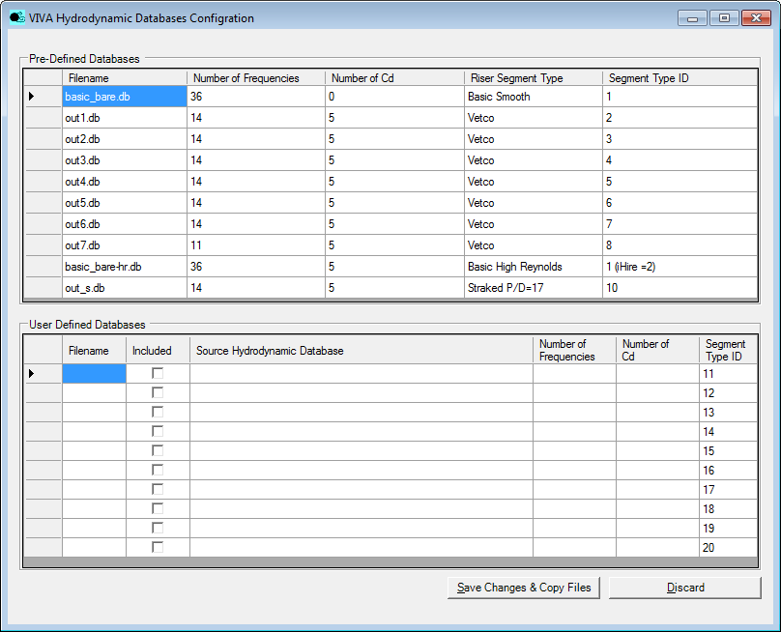

Figure .2 VIVA Database Management

Table .1 Format of Hydrodynamic Database File

|  |  |  |
| --- | --- | --- |
| Line | Name | Description |
| Repeat the following lines ( 1 to [NB+ 1] ) for every frequency, J = 1 to NA | | |
| 1 | Frequency (J) | Non-dimensional frequency |
| Lift (J) | Lift coefficient in phase with velocity at *A*/*D* = 0 |
| Added-mass (J) | The corresponding added mass |
| First slope (J) | The first slope of the lift curve |
| Second slope (J) | The second slope of the lift curve |
| A/D (J) | The value of *A*/*D* where the slope changes |
| Repeat Line 2 for every *Cd* value, K = 1 to NB | | |
| 2 | AMD(J,K) | The value of *A*/*D* |
| CD(J,K) | The corresponding drag coefficient |

* Number of Cd, NB: Number of Cd values to be given for each frequency as function of A/D

Note: The inputs should be strictly from top to bottom. De-selecting “Included” checkbox will de-select all databases below.

To confirm the input, click **Save Changes & Copy Files**. The source hydrodynamic files will be copied to the working directory as part of the hydrodynamic databases for VIVA and VIVARRAY.

## Project File Management

From the menu, select **File** / **New Project**. A dialogue box will be prompted (see Figure 2.3) for entering the project name and optional project description. After filling in the project name and clicking **OK**, a new project is created and ready for input. User can edit the project information later by selecting **File** / **Project Description**.

By using the **File** menu, the project file can be saved and opened like in any other Windows software applications.

When an existing project file is being opened, the program will also import the calculation results if they have already been generated by previous calculations. These results can be viewed and outputted through the **Computation** / **Results Front** or **Results Rear** menu (for details, see Section 4).

## Analysis Parameters Input

### Global Parameters

The global parameters are entered through the **Analysis Parameters** menu.

From the main screen, select **Analysis Parameters** / **Global Parameters**. A window, as shown in Figure 2.4, will apprear. Select and/or fill in the following information:

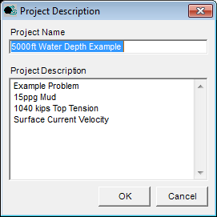

Figure .3 Project Description

* Units: The system of units in which the data will be entered and the results will be displayed

Note: Metric units by default.

* Damping Application Method

The user can choose between (a) modal damping, where if one specifies, for example 1% damping ratio, it means that each mode separately has the same modal damping ratio; or (b) constant damping, where only the first modal damping is calculated and the same value of damping (not damping ratio) is used for all other modes (hence higher order modes have increasingly smaller damping ratio).

Note: Modal Damping by default.

* Water Density

Note: 1025 kg/m³ by default.

* Water Viscosity

Note: 1.114 x 10-6 m²/sec by default.

* No. of Risers

Users can choose **One** or **Two** risers. If **One** riser is selected, inputs **Risers Location** will be disabled.

Note: One riser by default.

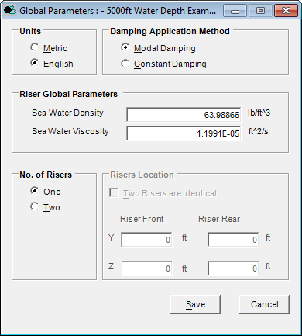

Figure .4 Global Parameters

* Two Risers Are Identical

Users can choose **Yes** or **No**. If **Yes**, the front riser properties will be copied to the rear riser.

* Riser Front & Riser Rear

Users can input the *Y* and *Z* coordinates of the riser top end location in the global coordinate.

Note: Y, Z coordinates are in the horizontal plane assuming the risers are perfectly vertical. For the rear riser, Y normally shows how far the rear riser is behind the front riser; and Z shows the side distance from the front riser. If the risers are SCR or lazy-wave risers, see Section 2.5.5.

To confirm the input, click **Save**

### Current Profile

Next from **Analysis Parameters** select **Current Profile**. An input window, as shown in Figure 2.5, will be displayed. Enter the following information into the appropriate fields:

* Profile Title
* Water Depth

Note: If the profile depth does not extend to the bottom of the riser, the program will assume that, in the deeper water, the riser would experience the same current velocity as the last input value.

The maximum number of water depths is 50.

* Current Velocity – *Y* Component

Current velocity in the *Y* direction. For SCR / Lazy Wave Risers, this is normally the current component in the riser plane.

* Current Velocity – *Z* Component

Current velocity in the *Z* direction. In the case of SCR / Lazy Wave Riser, this is normally the current component perpendicular to the riser plane.

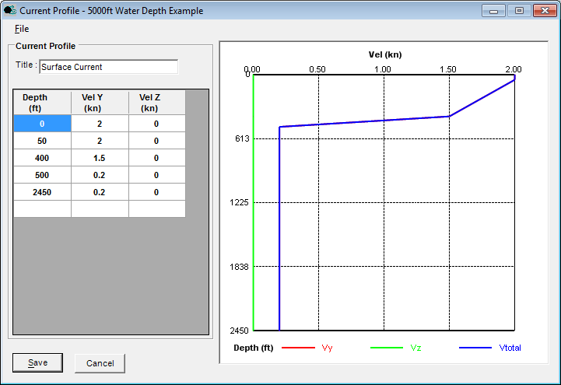

Figure .5 Current Profile

Note: The user can always right-click to delete a wrongly inputted row, insert a blank row for additional depth, or copy / paste from clipboard.

The current profile can be saved to a *.cur* file for future use in other projects by selecting **File / Export**. Once saved, the profile can then be used in any other project by using **File / Import**. The file format is provided in Table 2.2.

Then, click **Save** to save all changes made to this form and return to the main menu.

Table .2 File Format for .cur File

|  |  |  |  |
| --- | --- | --- | --- |
| Line | Name | Description | Remarks |
| 1 | NAME | Name of the current profile |  |
| 2 | UNIT | Units | 0 – metric units  1 – US units |
| Repeat Line 3 for each water depth (I = 1 to …) | | | |
| 3 | WD(I)  VELY(I)  VELZ(I) | Water depth, [m] or [ft]  Velocity in *Y* direction, [m/s] or [kn]  Velocity in *Z* direction, [m/s] or [kn] | In a single line |

### Refresh Main Menu

Next from **Current Profile** click **Refresh Main Menu**. The Main Menu will disable **Riser Rear** menu if the user chooses **One** in **No. of Risers** option in the **Global Parameters** input screen. The selection of **Computation / Results** **Riser Rear** will also be disabled. The Main Menu will enable **Riser Rear** menu after the user chooses **Two** in **No. of Risers** option. The selection of **Computation / Results** **Riser Rear** will also be enabled.

## Riser Data Input

### Riser Type and Boundary Conditions

Now the riser particulars need to be entered. From the main menu select **Risers** / **Riser Types and Boundary Conditions**. The screen in Figure 2.6 will be displayed. Select the type of riser (rigid drilling or SCR) and the desired upper and lower boundary conditions. Input the following information if required:

* Riser Top Tension

Note: If the upper boundary condition is set to Free End, the program will set this field to zero and disable the user’s input.

* Riser Top Location above Waterline

Note: Input negative value if below the waterline.

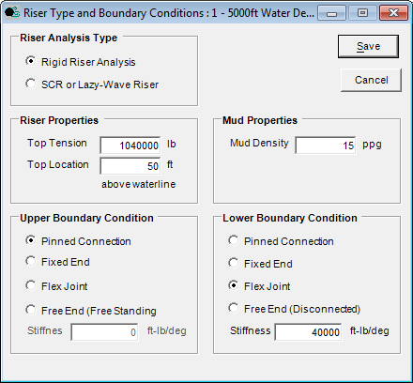

Figure .6 Riser Type and Boundary Conditions

* Mud Density
* Flex Joint Stiffness

Required when Flex Joint boundary condition is selected.

Click **Save** to save the riser data for use in the analysis.

### Segment Data

From the main menu select **Risers** / **Segment Data**. The screen in Figure 2.7 will be displayed. Input the following information if required:

Note: The riser information is entered from the bottom of the riser moving up for a maximum of 200 segments in the table. In other words, the first segment is always the bottom one.

* Main Tube Wall Thickness
* Number of Joints

The number of joints in the region with identical properties

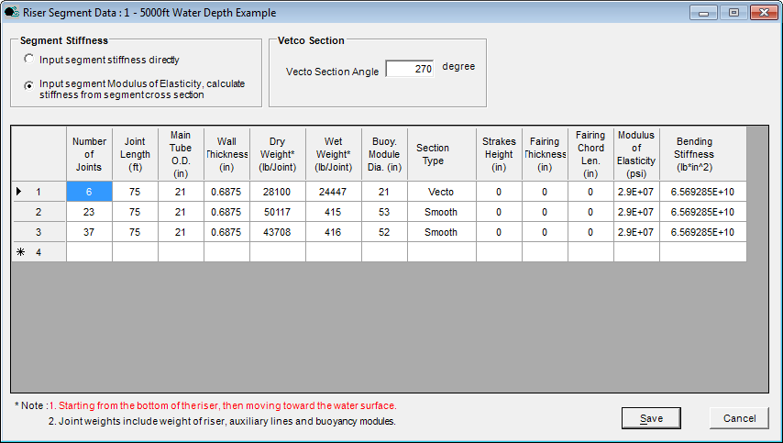

Figure .7 Riser Segment Data

* Joint Length
* Main Riser Tube Outer Diameter
* Dry Weight per Joint

Include the steel weight of riser and auxiliary lines, as well as the weight of buoyancy modules and fairings.

* Section Type

User may select a Section Type from smooth cylinder, Vetco joint, staggered bare-buoyant section, or straked riser with *H*/*D* = 0.2 and *P*/*D* = 17, as listed in Table 2.3. The definition of the Vetco Angle and attack angle of Vetco segment are depicted in Figure 2.8. A dropdown list is provided in the input screen to help the user select the proper section type.

For Vetco segments, the user will no longer need to choose a specific Vetco section type as before. Instead, the user will input a global Vetco Angle and the program will specify the proper Vetco section type based on the current profile and the global Vetco Angle.

Note: The dropdown list will appear once the corresponding cell is entered.

If “Straked” type is selected, the database obtained from experiments of VIVARRAY JIPs will be used. The properties of strakes in the experiments are H/D = 0.2 and P/D =17. In this case, the input strake height will be ignored.

If it is preferred to specify a particular strake height and use strake data from other literatures, the Section Type should be specified as “Smooth”.

For riser segments with fairings, the Section Type should be specified as “Smooth”.

Table .3 Riser Section Types

|  |  |
| --- | --- |
| Number | Section Type |
| 1 | Smooth Cylinder |
| 2 | Vetco Riser |
| 8 | Staggered Bare-Buoyant  (Default 1:3 ratio, with buoyancy Module as reference diameter) |
| 10 | Straked Riser  (3 strakes with *H*/*D* = 0.2 and *P*/*D* = 17) |

*Note: Vetco Riser segments are bare joints with choke & kill lines exposed to the current. Vetco angle and attack angle are defined as in Figure 2.8.*



*Y*

*Z*

Vecto Angle

Current Heading

Attack Angle

Vecto Heading

Figure .8 VETCO Angle Definition

* Strakes Height

Required if a particular strake *H*/*D* ratio other than 0.2 is used. The strake height is measured perpendicular to the surface of the riser.

Note: Data used in the program are valid for pitch to diameter ratios (P/D) larger than 4, up to a value of 20, preferably in the range of 5 to 8; and height to diameter ratios (h/D) larger than 0.05, preferably in the range of 0.06 to 0.15. See MODELING STRAKES AND FOIL SECTIONS IN VIVA.

If more than one segment has applied strakes, they must have the same height to diameter ratio.

In order to apply a specific strake height, the Section Type should be “Smooth”.

If “Straked” section is chosen in Section Type, Strakes Height will be ignored.

* Fairing Thickness

Required if fairings are applied.

Note: If a strake property is input, the program will assume there are no fairings applied on the same segment. See MODELING STRAKES AND FOIL SECTIONS IN VIVA.

* Fairing Chord Length

Required if fairings are applied.

* Modulus of Elasticity

Generally, it is 2.0×105 MPa (or 2.9×107 psi) for steel.

Note: The user can always right-click to delete a wrongly inputted row, insert a blank row for an additional segment, or copy / paste from clipboard.

After the main riser data has been entered, click **Save** button to return to the main menu.

### Auxiliary Lines

From **Riser** menu, choose **Auxiliary Line Data** option. In the data box, as shown in Figure 2.9, input the following data for each auxiliary line:

* Outer Diameter
* Inner Diameter
* Content Density

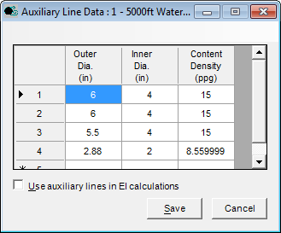

Figure .9 Auxiliary Line Data

Fill in as many lines as necessary (maximum 6). WinVIVA will automatically determine the total number of lines that are entered. The user can also include auxiliary lines into *EI* calculations by selecting the relevant checkbox, although this is not recommended.

Note: The user can always right-click to delete a wrongly inputted row, insert a blank row for an additional auxiliary line, or copy / paste from clipboard.

Once input is finished, click **Save** to return to the main menu.

### Intermediate Lateral Supports

Intermediate lateral supports can be considered in the analysis. From **Riser** / **Intermediate Lateral Supports** option. In the data box, as shown in Figure 2.10, input the following data for each support:

* Distance Along the Riser

Location of intermediate lateral support measured along the riser length from the top end.

* Spring Stiffness
* Damping Coefficient

Note: Start from the top most support

Fill in as many lines as necessary (maximum 100). WinVIVA will automatically determine the total number of lines that are entered.

Note: The user can always right-click to delete a wrongly inputted row, insert a blank row for an additional lateral support, or copy / paste from clipboard.

Click **Save** to return to the main menu.

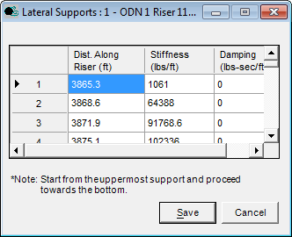

Figure .10 Intermediate Lateral Supports

### Additional information for SCR /Lazy-Wave Riser Analysis

If the SCR or lazy-wave riser option is selected, the user must supply the static configuration solution. Figure 2.11 shows the input screen for the additional information. When creating the file, the portion of SCR from the touchdown point on the seafloor to the wellhead is normally truncated in the VIV analysis. On the other hand, the user may choose to simulate the seabed by inputting intermediate lateral supports. Figure 2.12 shows the coordinate system used to describe the SCR riser configuration. The required information is outlined as follows:

Note: WinVIVA only applies a simplified model in which the static configuration of SCR or lazy wave riser is always in the XOY plane. However, DOS VIVA is capable of handling cases with 3-D static configuration.

For catenary riser, the portion of the riser lying on the floor shall be truncated in general. With the introduction of intermediate lateral supports, the grounded portion may be modeled as lateral supports.

* Distance along Riser, *S*

Measured from the bottom end to the point in consideration. Inputs start from the top end.

Note: The first point is always the top point.

* Axial Static Tension, *T*
* In-Plane Riser Angle, *α*

In the riser plane with current and measured from the horizontal.

* Depth

Water depth at the current point.

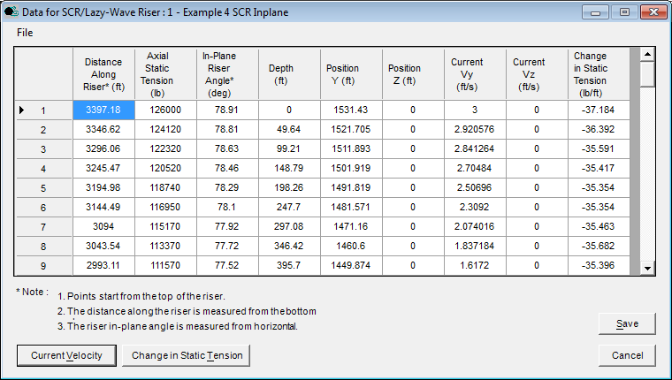

Figure .11 SCR / Lazy-Wave Riser Data

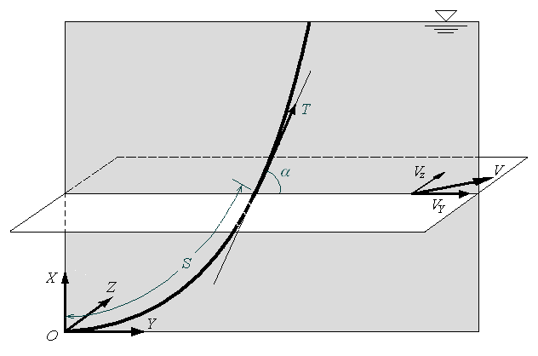

Figure . SCR / Lazy Wave Riser Configuration and Definitions

Note: Negative if above waterline.

* Node Position – *Y* Component

Horizontal distance at current node measured in the riser plane from the riser bottom end. This is an optional input for a single riser case, but is mandatory for VIVARRAY.

* Node Position – *Z* Component

Horizontal distance at current node measured perpendicular to the riser plane from the riser bottom end. This is an optional input for a single riser case, but is mandatory for VIVARRAY.

* Current Velocity – *Y* Component, *VY*

Current component in the riser plane. Can be calculated from the input current profile by clicking **Current Velocity**.

* Current Velocity – *Z* Component, *VZ*

Current component perpendicular to the riser plane. Can be calculated from the input current profile by clicking **Current Velocity**.

* Change in Static Tension

Can be estimated by clicking **Change in Static Tension** button. The value should be negative when riser has a positive wet weight.

Note: The maximum number of points is 6,001.

The user can always right-click to delete a wrongly inputted row, insert a blank row for an additional point, or copy / paste from clipboard.

The user can prepare the input data using other utilities, and then import into WinVIVA through **File** / **Import Static Solution**. The file format is described in Table 2.4.

Once the input is finished, click **Save** to return to the main menu.

Table . File Format for Import Static Solution

|  |  |  |  |
| --- | --- | --- | --- |
| Line | Name | Description | Remarks |
| 1 | NUMP | Number of Points | Maximum 6,001 |
| 2 | UNIT | Units | 0 – metric units  1 – US units |
| Repeat Line 3 for each point (I = 1 to NUM), starting from the top most point | | | |
| 3 | DIST(I) | Distance along the riser, [m] or [ft] | Measured from bottom end |
| TEN(I) | Axial Static Tension, [N] or [lb] |  |
| ANGLE(I) | In-plan Riser Angle, [deg] | Measured from horizontal |
| DEPTH(I) | Depth, [m] or [ft] |  |
| Position Y | From Down Stream direction[m]/ [ft] |  |
| Position Z | Transverse from Y [m] or [ft] |  |

### Other Riser Properties

Other riser properties can be input through **Riser** / **Other Riser Properties** option. In the data box, as shown in Figure 2.13, input the following data for each support:

* Structural Damping Ratio (Zeta)

The user must specify the structural damping as a fraction of the critical damping of the system. Typically the damping is in the range of 0.01 to 0.07 (1% to 7% critical). Trends are as follows:

* For a uniform flow, this parameter may play a very significant role in the drag amplification and must be evaluated accurately.
* For shear flows, the role of critical damping is significantly less important.

An estimate of the importance of the structural damping can be found from the parameter *Q*:

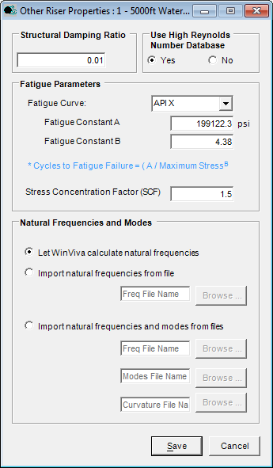

Figure .13 Input of Other Riser Properties

 [2.1]

where *St* = Strouhal number (0.17)  
*ρc* = density of pipe material (usually steel)  
*ρw* = density of water

*Q* is the ratio of the structural damping to the hydrodynamic damping, hence some general trends for the parameter are:

* If *Q* ~ 1.0 (or higher), *ζ* is very important.
* If *Q* << 1.0, *ζ* does not have a large effect.
* For higher shear flows, structural damping is less important

Note: 0.01 by default.

* High Re Data

The user can specify whether to use the high Reynolds number database developed from the high Reynolds experiments.

Note: Using the high Reynolds number database by default.

* Fatigue Curves and Contants *A* and *B*

The fatigue curves are defined as:

 [2.2]

where *N* = number of cycles to fatigue failure  
*S* = maximum stress value (amplitude)  
*A* and *B*, constants

The program has included a database of fatigue curves, including the HSE and API curves, which are listed in Table 2.5 and Table 2.6. Users can select one of them through the dropdown list. The constants *A* and *B* will be updated accordingly.

* Stress Concentration Factor (SCF)

Note: 1.5 by default.

* Natural frequencies and modal shapes

By default, WinVIVA will calculate the natural frequencies and modal shapes for the analysis. Users have the option to import natural frequencies and/or modal shapes calculated by other programs into WinVIVA. When selecting import from external files, the corresponding textbox and **Browse** button will be activated to input the filename. File formats for importing frequencies and modal shapes are provided in Table 2.7 and Table 2.8, respectively.

Table 2.5 Constants for HSE Fatigue Curves

|  |  |  |  |
| --- | --- | --- | --- |
| Class | A | | B |
| (MPa) | (psi) |
| B | 2827.9 | 410152 | 4 |
| C | 3919.7 | 568504 | 3.5 |
| D | 5740.8 | 832633 | 3 |
| E | 5077.3 | 736400 | 3 |
| F | 4288.5 | 621994 | 3 |
| F2 | 3763.9 | 545908 | 3 |
| G | 3130.7 | 454070 | 3 |
| W | 2705.8 | 392443 | 3 |
| T | 5653.3 | 819932 | 3 |

Table 2.6 Constants for API RP-2A Fatigue Curves

| Curves | A | | B |
| --- | --- | --- | --- |
| (MPa) | (psi) |
| X | 1372.7 | 199093 | 4.38 |
| X’ | 1911.5 | 277240 | 3.74 |

Table . Format of Frequency File

|  |  |  |  |
| --- | --- | --- | --- |
| Line | Name | Description | Remarks |
| For each mode I, repeat line 1 | | | |
| 1 | I | Mode Sequence Number | Maximum NP/7 |
| FREQ(I) | Modal Frequency [rad/sec] |  |

Table . Format of Modal Shape and Curvature Files

|  |  |  |  |
| --- | --- | --- | --- |
| Line | Name | Description | Remarks |
| For each mode I, specified in *FREQ.in*, repeat line 1 for every nodes from J = 1 to NP_R starting from the top end | | | |
| 1 | X(J) | Axial Distance of Node J [m] | Measured from the top end |
| Y_R(I,J) | Real Part of Displacement or Curvature at Node J [m] |  |
| Y_I (I,J) | Imaginary Part of Displacement or Curvature at Node J [m] | Equals 0 if the modes are standing modes |

Note: The minimum frequency number is 1, but one should consider that the program predictions may be inaccurate if too few modes are specified.

The number of modes must be the same as the number of frequencies specified in the frequency file.

When importing modal shapes, both the modal shape and curvature files are needed in addition to the frequency file.

To confirm the input, click **Save**.

# running an analysis case

## Running the Current Case

Once the required data in Section 2 is entered, a VIVA or VIVARRAY case run can be made by selecting **Computation / Calculating Now** from the main screen menu to launch the input and execution screen in Figure 3.1.

The final inputs needed before starting the analysis are the number of iterations and number of points (nodes) in the analysis.

Note: The number of iterations must be at least 30, and the number of points should be at least 200. The accuracy of the program improves as these numbers increase. However, the computation time increases dramatically when there are more than 1,000 nodes. The maximum node number is 6,001. It is recommended to choose an iteration number less than 100.

If analyzing two risers, both risers will have the same node number.

Whether or not DOS windows are visible during the execution can also be selected here.

By selecting **Run**, WinVIVA will execute VIVA or VIVARRAY programs and generate output reports. The run time for any given analysis will vary depending on the number of iterations, nodes, riser regions, and complexity of the current profile being analyzed. Users are advised to be patient while calculations are underway. The user also has the choice to generate VIVA or VIVARRAY input files by clicking **Generate Input** so that he or she can run VIVA directly in the DOS environment.

Note: It is required to save a new project through the File menu before running VIVA programs. This is because WinVIVA will attempt to store the output files in the same directory as the input data file. It will also prevent the loss of input data. For an existing project, although not mandatory, it is recommended to do so for protecting inputs.

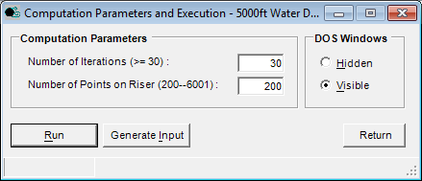

Figure .1 Computation Parameters and Execution

## Batch Process for Multiple Currents

In many cases, the user needs to run multiple current VIV analysis for a single riser or two risers configuration. In the WinVIVA 8.2 package, a batch process program is included for multiple current VIV analysis. The user can start the batch processor by selecting **Computation / Batch Processing** from the main screen menu.

Detailed instruction of running the batch processor is presented in Section 6 of this document.

## Additional Notes on the Program Use:

1. Number of Points for Calculations: Note that up to 6001 equidistant points may be used for numerical calculations. Make sure that at least three points are included in each segment, particularly in cases where small segments are used, like when representing a flexible joint. It is best to reduce the number of segments, if needed, to ensure adequate resolution. Consult with Prof. M. Triantafyllou for further advice.
2. Running Time: When VIVA calculates natural frequencies and modes, the execution time depends on the third power of the number of points used. For example, doubling the number of points means 8-times longer running time. When the natural frequencies are input externally (calculated by a different software, such as a finite element code), then the time of execution is almost linearly varying with the number of points. Hence, if you run the program for several velocity profiles but with the same top tension and the other material properties, it is best to run it once in the beginning with internally calculated frequencies and modes, and then store the results to use them as input for the remaining cases, as externally input modes. This will reduce the running time greatly, especially when a large number of points is needed.

Note: The above optional databases should be input as:

basic_bare-sche 36 0

basic_bare-07 36 0

basic_bare-14 36 0

out_hr.in 77 61

1. Basic Hydrodynamic Database to Use: The program always requires a standard database for a smooth cylinder (for other riser sections consult the manual, but note that the smooth cylinder database must always be present and specified in *no_files.in*). The file *basic_bare.db* is the standard file for subcritical Reynolds numbers, accounting for in-line motion effects. It is a conservative approach, always assuming the worst case scenario for the effect of in-line motion. It has been extensively tested against uniform and linearly sheared profiles in subcritical Reynolds number. The file *basic_bare-07* has been tested with GoM sheared profiles and is less conservative than *basic_bare-14* for subcritical Reynold numbers. The *basic_bare-hr.db* is a conservative high Reynolds number file. The file *basic_bare-sche* has been tested for high Reynolds number cases in GoM sheared profiles.
2. Riser-Soil Interaction: You can model the riser-soil interaction by specifying a number of distributed linear springs and linear dashpots.

# Description of Output

WinVIVA copies a set of output files generated by DOS VIVA or VIVARRAY into the data directory. It allows for easy review of these analysis results by presenting them in both tabular and plot formats.

## Tabulating Results

To facilitate reporting of VIVA analysis results, select **Computation / Results Riser Front** from the main menu. For VIVARRAY results, select **Results Riser Front** for the front riser and **Results Riser Rear** for the rear riser. Figure 4.1 shows the screen in which a summary of the analysis results is presented for the front riser

Note: Fatigue Location in Figure 4.1 is the location of minimum fatigue life from the top of the riser. The maximum amplitude for the multi-frequency response is the maximum RMS amplitude.

WinVIVA is able to report detailed results to a Microsoft Excel file with the following options

* MM: report the multi-frequency results only;
* All by Mode: report all the results separated by the mode; or

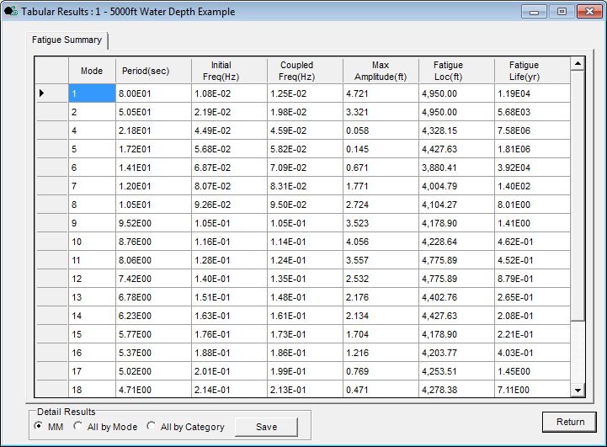

Figure .1 Tabulated Results

* All by Category: report all the results separated by the result category.

Choose an option, and click the **Save** button to save the results to an Excel file.

Note: Due to the size of output files, it may take several minutes when choosing to report all the results.

All stress results from WinVIVA are dynamic stresses, or bending stresses, caused by vibration.

## DOS Output Files

WinVIVA copies all output files generated by DOS VIVA or VIVARRAY to the project data directory. The user should consult the *User’s Manual DOS Version 8.4* for detailed information.

# example problems

## Single Riser Examples

To aid the user in becoming familiar with the software, five example single riser problems are outlined in this section that cover the various riser options available during analysis, such as rigid risers in connected and disconnected modes, steel catenary risers, and free-standing risers. These examples are briefly described as follows:

* Example 1 is a rigid riser in 10,000 ft water depth with GOMEX 3.5 knots loop current (Figure 5.1). The riser has a pinned upper and lower boundary conditions;
* Example 2 is the above example in disconnected, or hang-off, condition (Figure 5.2);
* Example 3 is a 3000 ft riser in WOS 1.0 m/s current (Figure 5.3). The riser has a flex-joint at the bottom;
* Example 4 is a steel catenary riser in 2790 ft water depth with GOMEX 3.0 knots eddy current (Figure 5.4); and
* Example 5 is a 4750-ft free-standing riser in 5000 ft water depth with Brazil current (Figure 5.5).

The WinVIVA and DOS VIVA input files of these examples are included with the software package and will be installed in the directory of *..\Examples\Single Riser*.

## Two-Riser Examples

There is an example problems for two interactive risers, which are defined as follows:

* Example 4, which has two identical SCRs as the riser in Example 4 of the single riser examples.

The WinVIVA and DOS VIVARRAY input files of these examples are included with the software package and will be installed in the directory of *.\Examples\Two-Riser*.



Top Tension = 2400 kips

Mud Density = 8.6 ppg

Figure . Example Problem 1:  
10000-ft Riser in GOMEX 3.5kt Loop Current  
Pinned Upper and Lower Boundary Conditions



Top Tension = 2624 kips

Mud Density = 8.6 ppg

Figure . Example Problem 2:  
10000-ft Riser in GOMEX 3.5 kt Loop Current  
Pinned Upper and Free Lower Boundary Conditions



Above-Water Height = 100 ft

Top Tension = 1000 kips

Mud Density = 9 ppg

Figure . Example Problem 3:  
3000-ft Riser in WOS 1.0 m/s Current  
Pinned Upper and Flex-Joint Lower Boundary Conditions



Figure . Example Problem 4:  
SCR Riser in 2790-ft Deep Water, GOMEX 3.0 kt Current  
Pinned Upper and Lower Boundary Conditions



Top to Waterline = 250 ft

Mud Density= 8.6 ppg

Figure . Example Problem 5:  
4750-ft Free-Standing Riser in 5000ft WD, Brazil Current Profile  
Free Upper and Pinned Lower Boundary Conditions

# WinVIVA Batch Processor

WinVIVA batch processor is a program added to the WinVIVA 8.2 package for performing multiple current VIV analysis for a single riser from a pre-configured WinVIVA project. Support for VIVARRAY analysis has been planned for future development.

This program can be located in the WinVIVA 8.2 installation directory as “WinVIVA Batch.exe”. The user can start the program from the installation directory directly or by selecting **Computation / Batch Processing** from the main screen menu in WinVIVA, and then the window as shown in Figure 6.1 will show up for the batch analysis. This section will guide the user on how to use the batch processing tool.

## Requirements

To be able to use the batch processor, the user should have a pre-configured WinVIVA project created in in WinVIVA 8.2 that has been tested to be error free. The user should also have a copy of Microsoft Excel installed in order to read the batch analysis results in the batch processor.

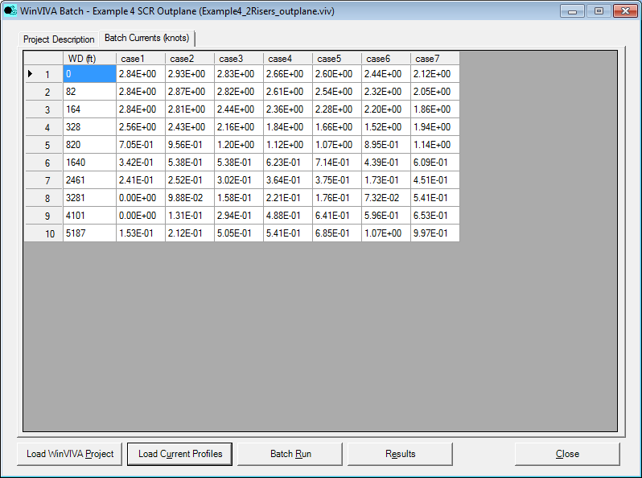

Figure . WinVIVA Batch Processor Main Screen

## Current profiles

The current profiles should be stored in a comma delimited text file. The user can prepare the current profiles using Microsoft Excel and save it as a .*csv* file, or the user can prepare the file using a text editor such as Notepad or WordPad. A sample current file, *current.csv*, can be found under: *..\Examples*, which looks like the following:

0,2.84E+00,2.93E+00,2.83E+00,2.66E+00,2.60E+00,2.44E+00,2.12E+00

82,2.84E+00,2.87E+00,2.82E+00,2.61E+00,2.54E+00,2.32E+00,2.05E+00

164,2.84E+00,2.81E+00,2.44E+00,2.36E+00,2.28E+00,2.20E+00,1.86E+00

328,2.56E+00,2.43E+00,2.16E+00,1.84E+00,1.66E+00,1.52E+00,1.94E+00

820,7.05E-01,9.56E-01,1.20E+00,1.12E+00,1.07E+00,8.95E-01,1.14E+00

1640,3.42E-01,5.38E-01,5.38E-01,6.23E-01,7.14E-01,4.39E-01,6.09E-01

2461,2.41E-01,2.52E-01,3.02E-01,3.64E-01,3.75E-01,1.73E-01,4.51E-01

3281,0.00E+00,9.88E-02,1.58E-01,2.21E-01,1.76E-01,7.32E-02,5.41E-01

4101,0.00E+00,1.31E-01,2.94E-01,4.88E-01,6.41E-01,5.96E-01,6.53E-01

5187,1.53E-01,2.12E-01,5.05E-01,5.41E-01,6.85E-01,1.07E+00,9.97E-01

In the file, the first data column is the water depth from surface to bottom while the other columns are the current profiles with each column representing one current profile.

Note: The unit of the water depth should be consistent with the unit used in the project file, which could be foot (feet) or meter(s) depending on the units used in the project.

The unit of the current velocities is knot(s).

At this stage, the batch processor supports only one dimensional current. The direction of current profiles is the direction of the top most non-zero current in the current profile of the base project.

## Running Batch Analysis

With a pre-configured project file and a current profile file, running the batch analysis will be straightforward with the following sequence indicated by the buttons in the program:

**Load WinVIVA Project → Load Current Profiles → Batch Run → Results**

At the start of the program, only the **Load WinVIVA Project** button will be enabled. The button of each next step will be activated once the previous step is successfully finished.

## Analysis Results

Batch analysis results generated by VIVA will be located in the directory where the project file is located.

The batch analysis results will be gathered into an Excel file for Single-Mode / Multi-Mode fatigue lives, and Single-Mode / Multi-Mode displacements. The single mode results represent the modes with the least fatigue life only.

Additional result gathering is not available yet, but will be considered in the future development.